Exception-Utils Implementation

This document represents the analysis to implement Custom Exception Response for microservice. The process/ steps involved to do this stated in this document. Also the main changes required to the existing codebase is displayed in compare screenshots using a particular endpoint for this test.

Functional discussion document : 

Pictorial Representation of the Exception Structure:

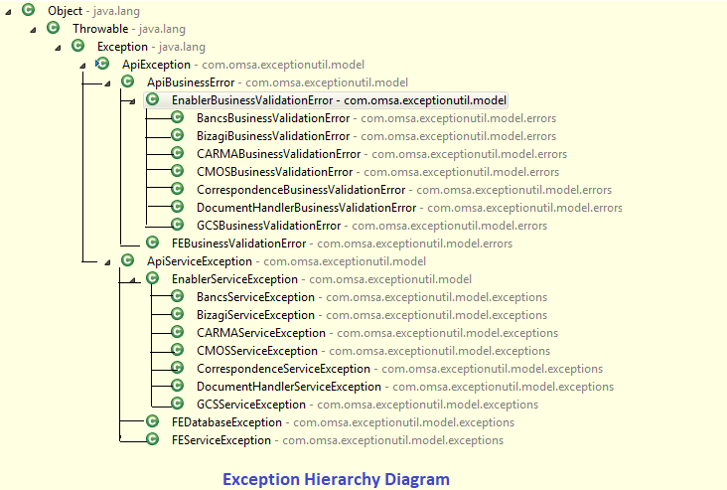

Steps to Proceed:

Versions of Exception-Utils :

* If the component is having spring boot : v1.5.22, then use omsa-exception-utils v1.0.1.
* If the component is having spring boot : v1.4.7, then use omsa-exception-utils v0.0.7.
* If the component is having sprint boot : v1.4.0, then use omsa-exception-utils v0.1.0.

SPING BOOT MICROSERVICE CHANGES :

1. Put the dependency of Exception-Utils in pom.xml of spring boot maven microservice.
2. Include ApiExceptionandlerAdvice.java in SrmComponentServicing.java class.
3. Add the attribute additional.exception.details in application.properties file for the required result.
4. Call using ExceptionUtilApplication.doRestExchange() method during rest calls
5. Throw the exception using throws from the methods involved throughout the call.
6. Make the required changes in test case also, if required.

Changes Required :

Test done using /allpolicies endpoint. For that we need to proceed with few changes. The main differences are shown below.

The left part represents the new code and the right side represents the currently running code.

Changes log for BPL/BSL :

LEFT is OLD, RIGHT is MODIFIED :

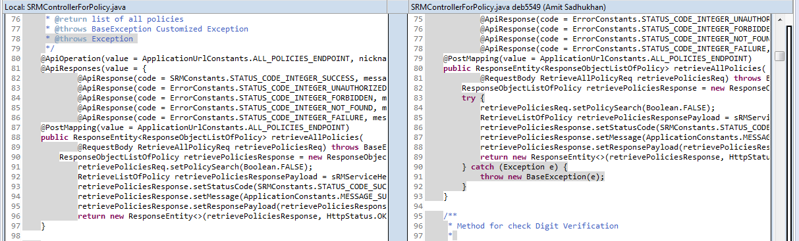

LEFT is OLD, RIGHT is MODIFIED

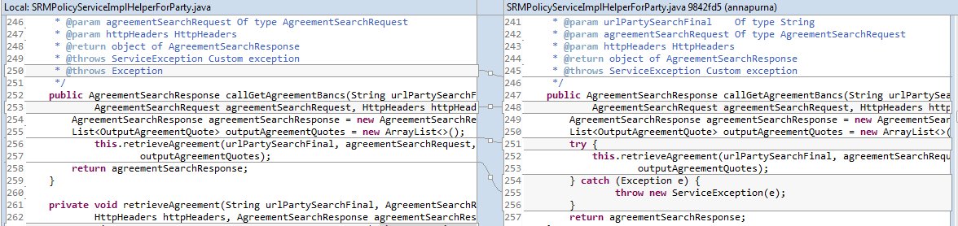

LEFT is OLD , RIGHT is MODIFIED

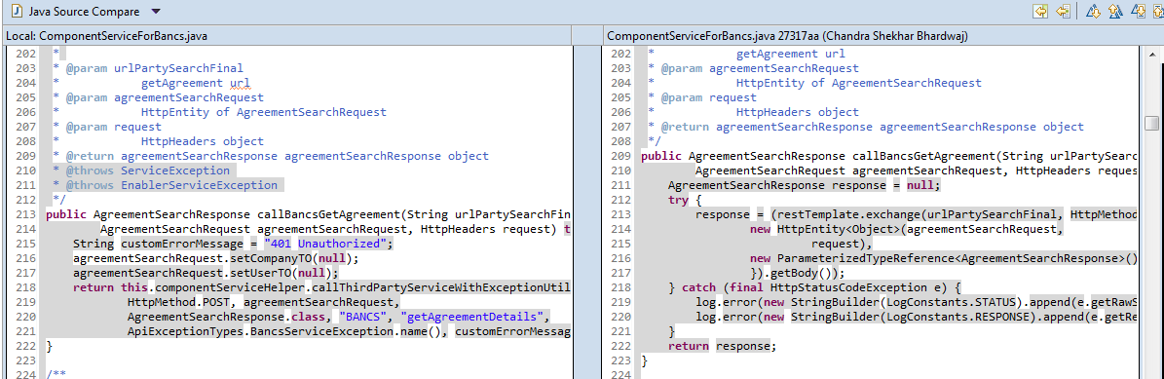

CHANGE LOG FOR BFF :

LEFT is OLD, RIGHT is MODIFIED

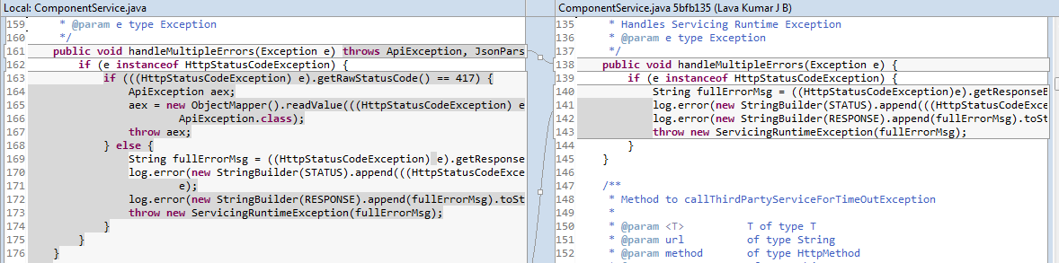

Response Class Structure:

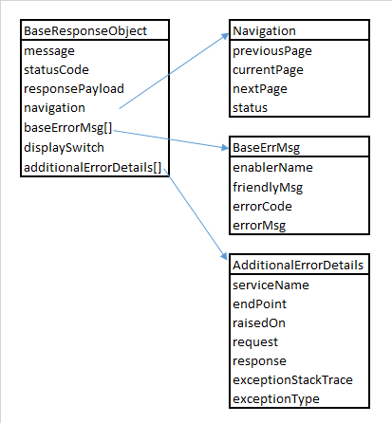

Sample Error Response from SRM for /allpolicies endpoint:

